Year 8 Science
Earth and Space Sciences
Revision - The Dynamic Earth

1. (a) Which layers of the Earth have the following characteristics?

• Completely molten

• Partially molten

• Includes solid rock, soil and landforms

• Solid and mostly made up of iron

• Lies above the surface

(b) Draw a simple labelled diagram showing the layers of the Earth.

2. Describe two pieces of evidence that supported Wegener’s theory of continental drift.

3. According to the theory of plate tectonics, the Earth’s crust is divided into a number of slowly moving plates.

(a) What makes the plates move?

(b) What can happen when two plates slide past each other?

(c) How does the plate tectonics theory explain the increasing height of the Himalayas?

4. Where on Earth is the Ring of Fire and why does it exist?

5. How is an ocean ridge different from a subduction zone?

6. When oceanic crust pushes against continental crust, why does the oceanic crust slide underneath the continental crust?

7. Describe the movements in the Earth’s crust that cause the folding of rock that has shaped most of the Earth’s mountains.

8. Explain how faults are created.

9. Label the following diagrams using the following words:

anticline, continental crust, magma, normal fault, oceanic crust, reverse fault, solid upper mantle, syncline.

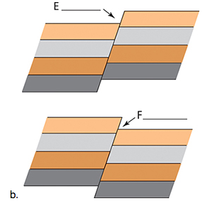
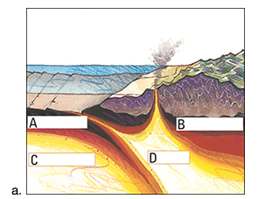

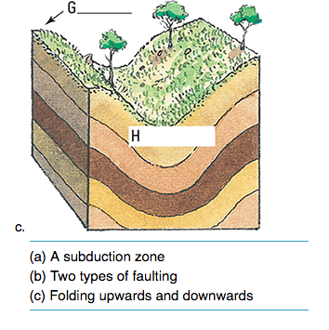

10. The San Andreas Fault makes much of coastal California, including the cities of Los Angeles and San Francisco, susceptible to earthquakes.

(a) Explain why the San Andreas Fault is called a slip fault.

(b) What causes major earthquakes along this fault?

11. Distinguish between the epicentre of an earthquake and its focus.

12. What is a seismograph used to measure?

13. Explain why Australia is less likely to experience volcanic activity and major earthquakes than New Zealand.

14. Before a volcano erupts, its vents are blocked with thick, pasty lava.

(a) What change takes place to cause the volcano to erupt?

(b) How is the lava emerging from a volcano different from magma?

15. Distinguish between a dormant volcano and an extinct volcano.

16. (a) How do volcanoes form?

(b) Draw a simple labelled diagram to show the major parts of a volcano.

(c) Name the three different types of volcanoes.

(d) Where on the Earth's surface are most volcanoes found? Explain why this is so.

17. (a) What is a tsunami and how is it formed?

(b) How is a tsunami different to a "normal" wave we see on our beaches?

(c) Why do tsunamis cause so much damage as they near land?

